**Spring Data JPA with Hibernate Part-3**

**Exercise**

1. **Create a class Address for Author with instance variables streetNumber, location, State.**

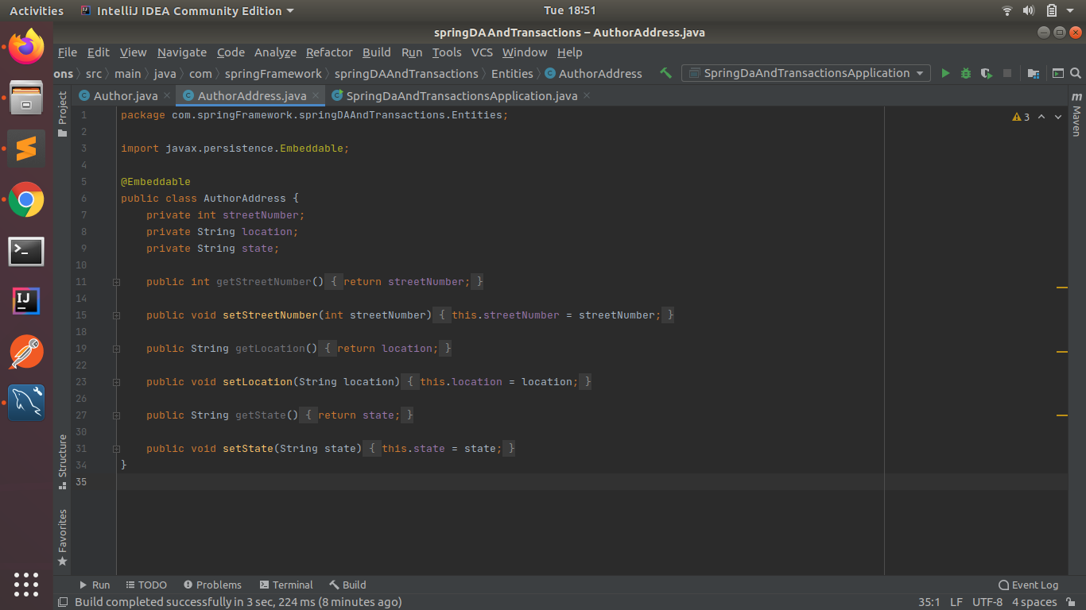

1. **Create instance variable of Address class inside Author class and save it as embedded object.**

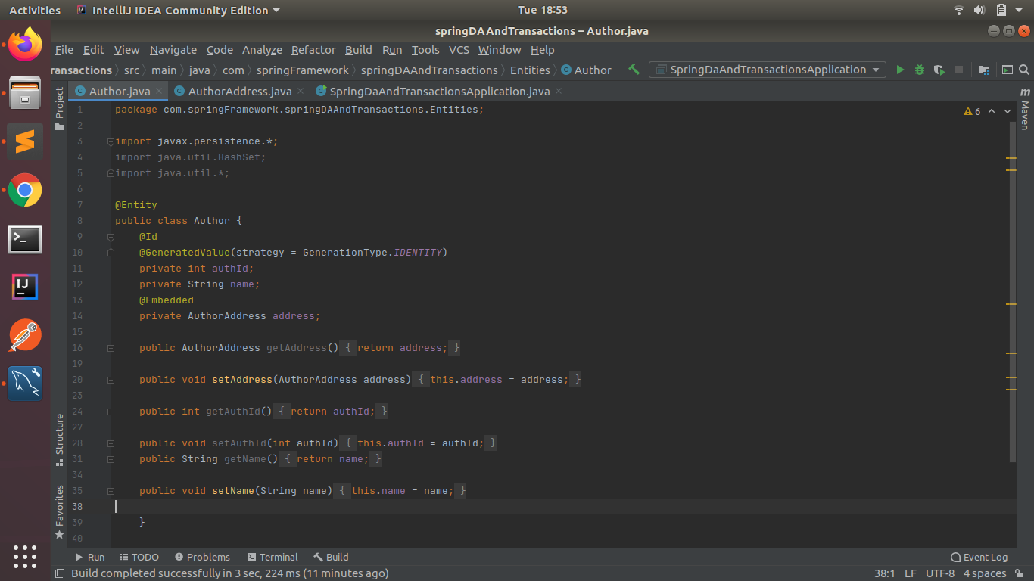

1. **Introduce a List of subjects for author.**

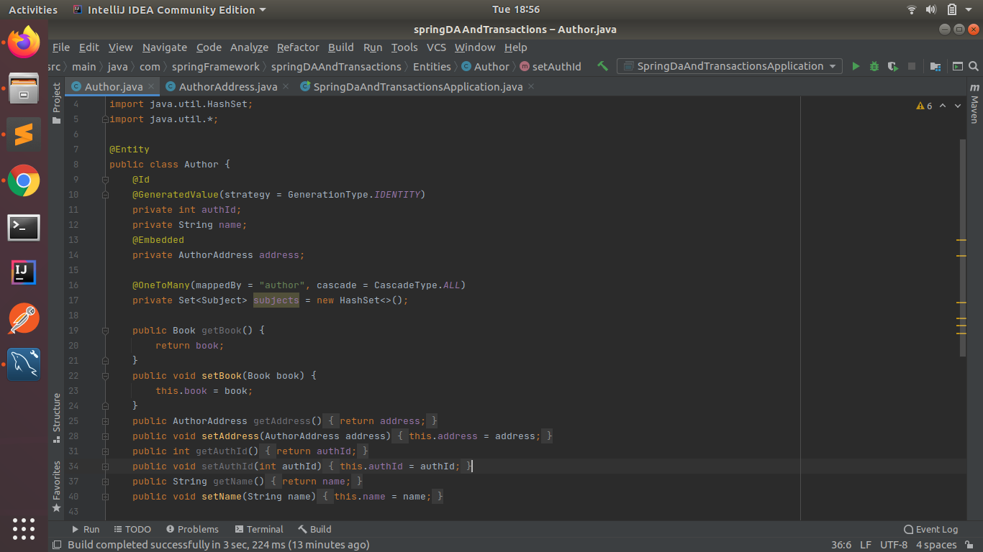

1. **Persist 3 subjects for each author.**

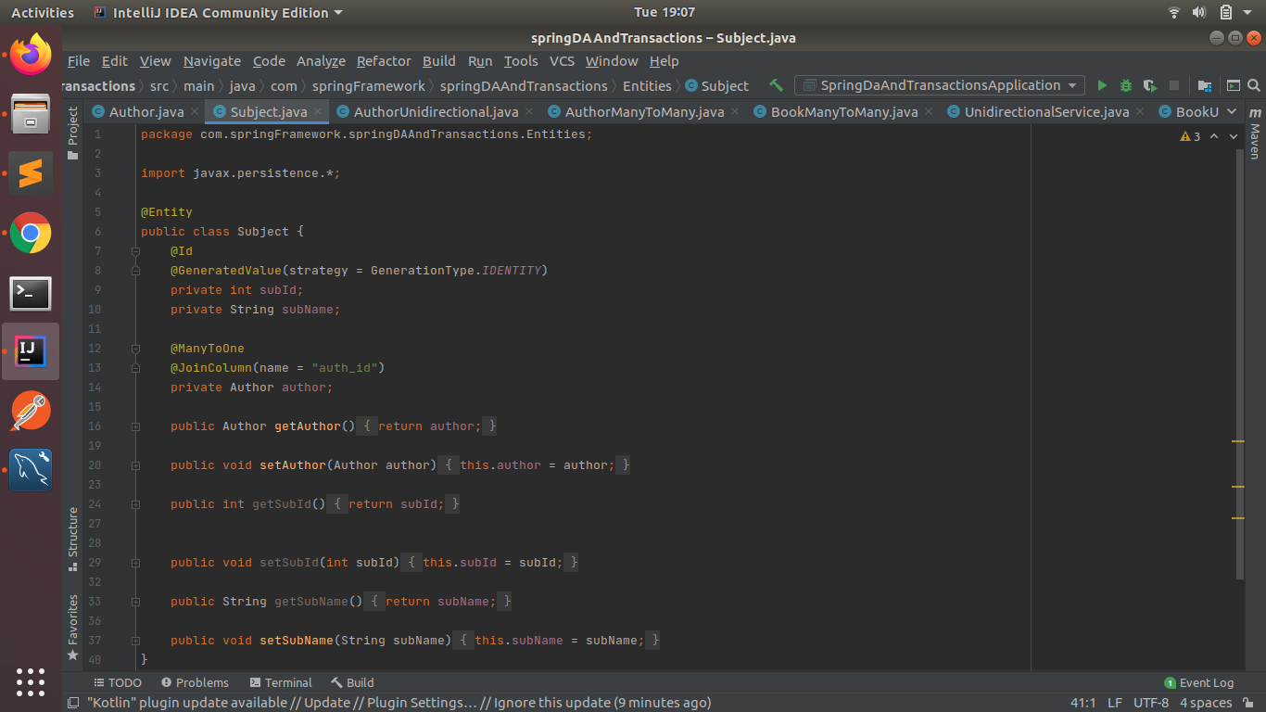

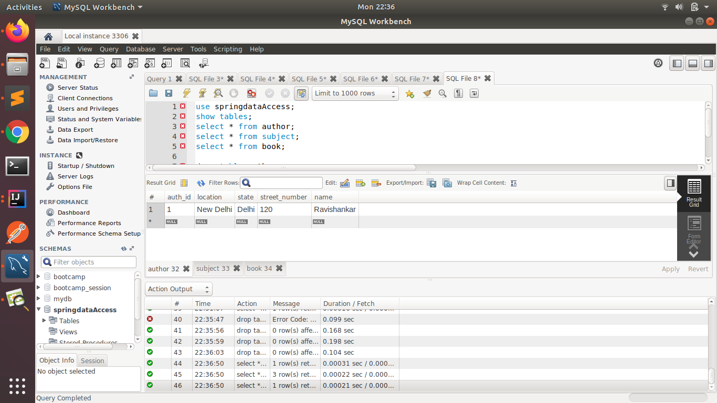

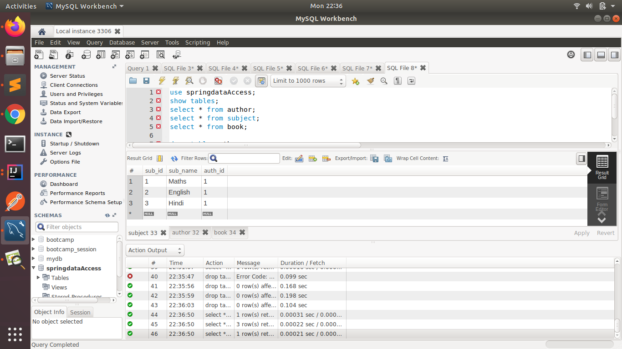

1. **Create an Entity book with an instance variable bookName.**

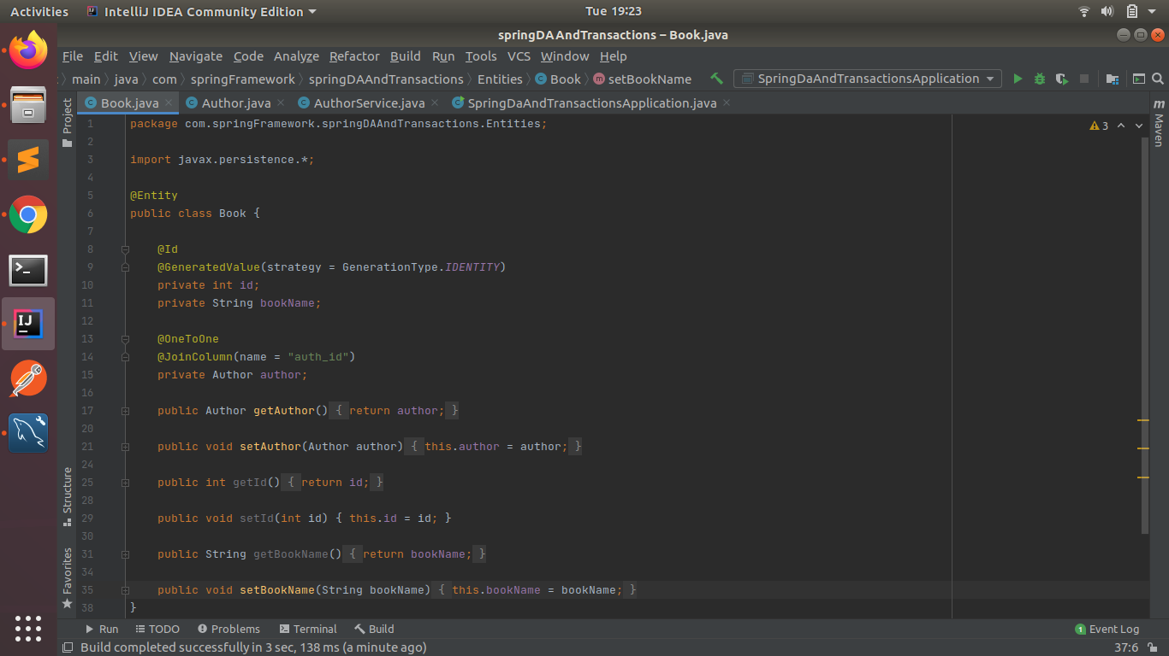

1. **Implement One to One mapping between Author and Book.**

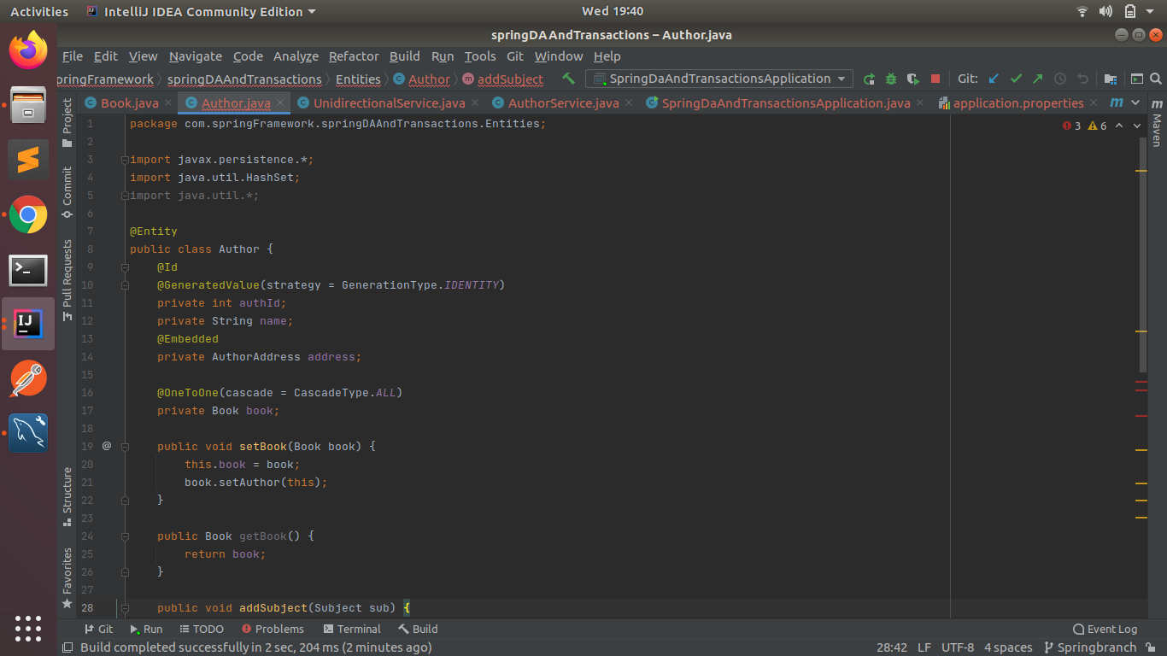



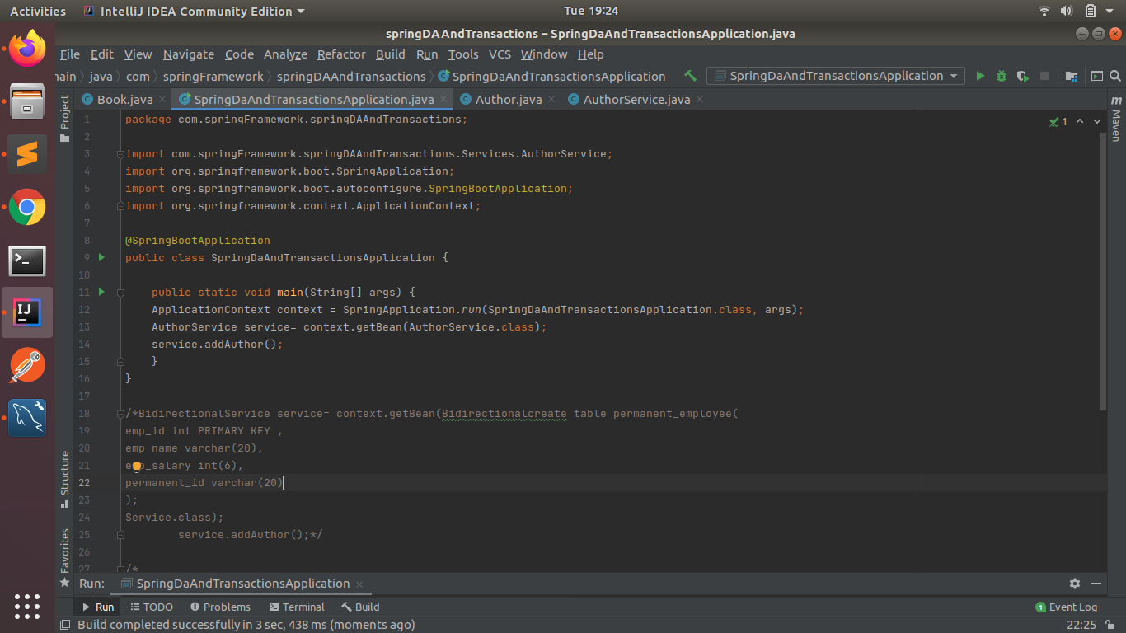

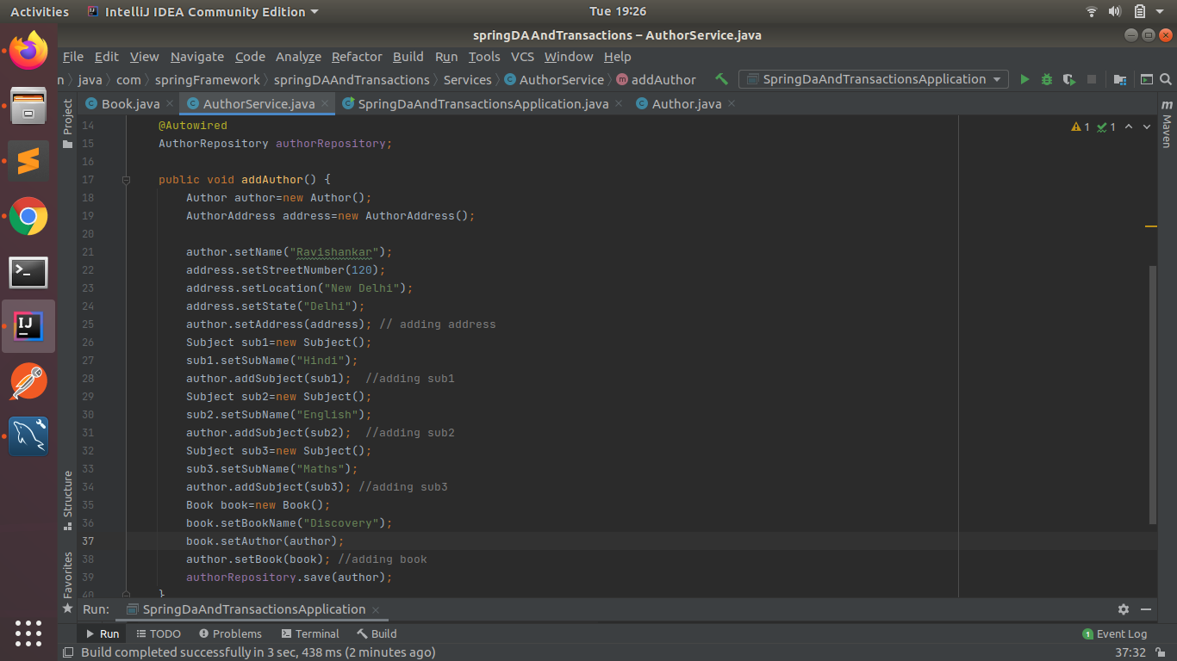

**Author Table:**

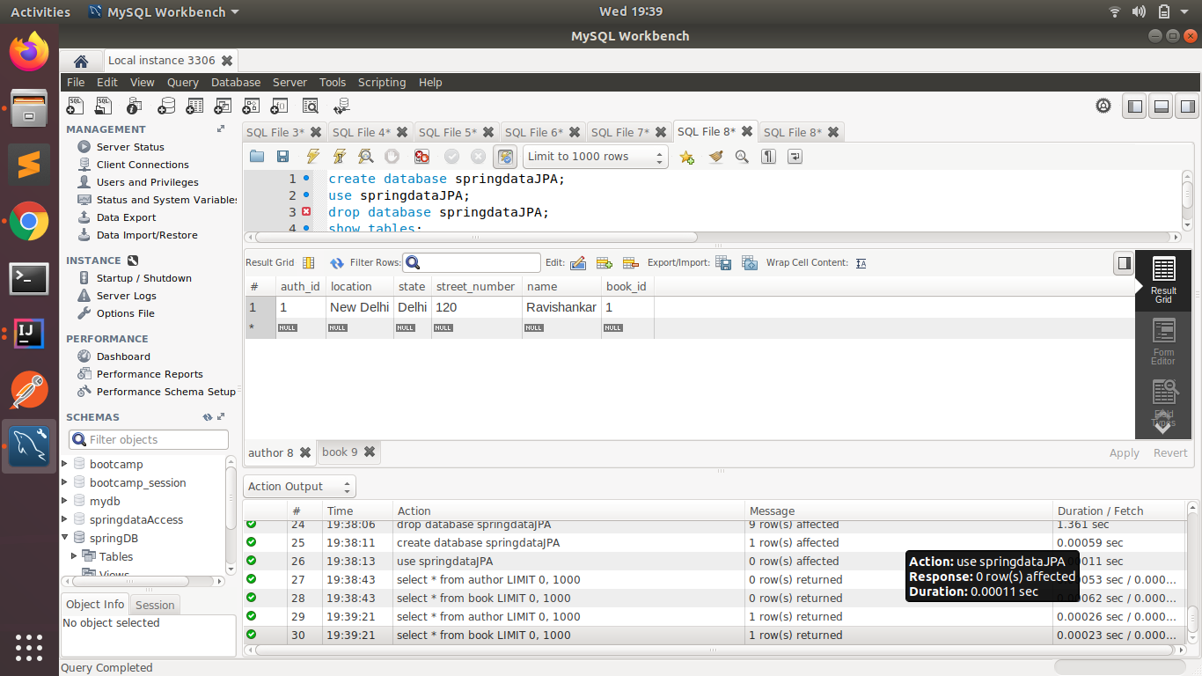

**Book Table:**

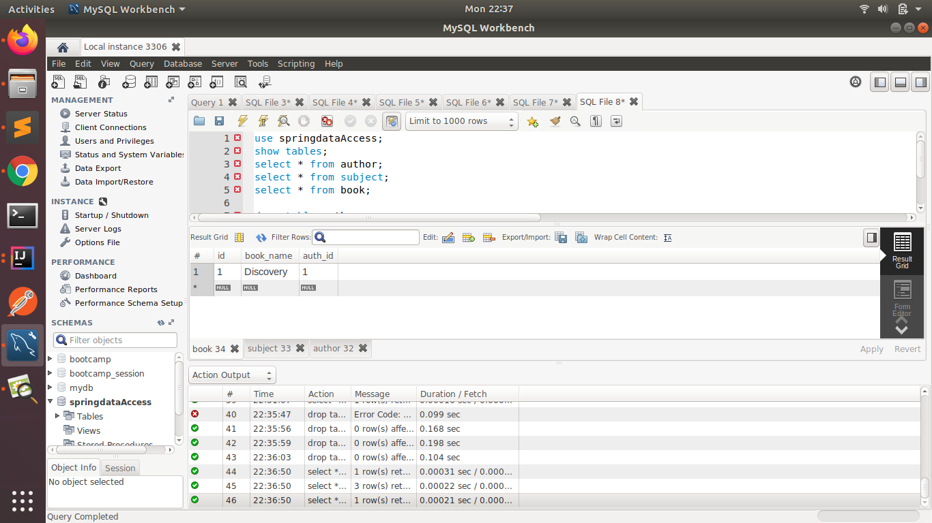

1. **Implement One to Many Mapping between Author and Book(Unidirectional, BiDirectional and without additional table ) and implement cascade save.**

UNIDIRECTIONAL:

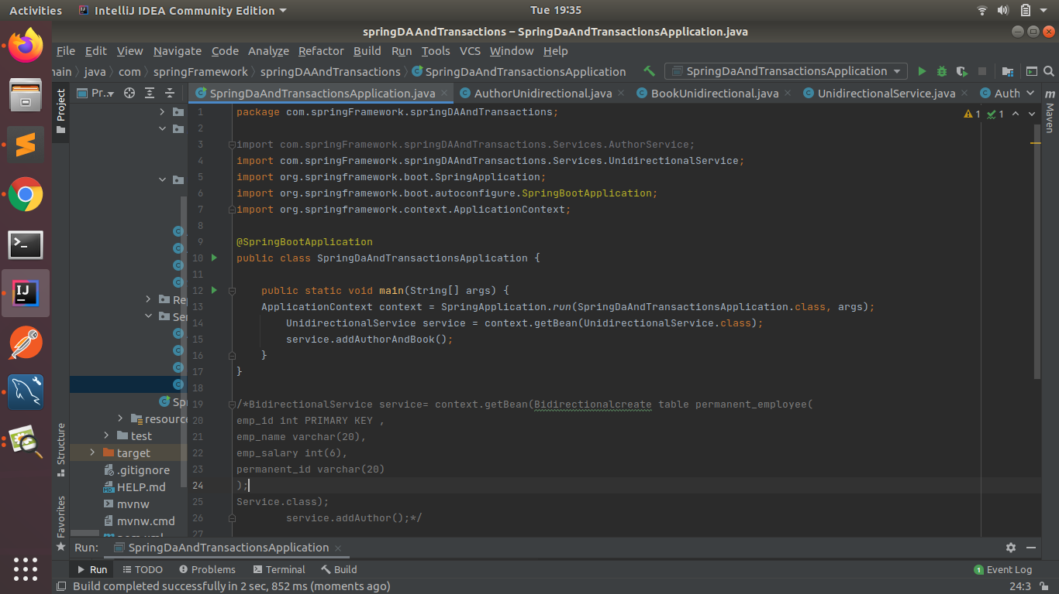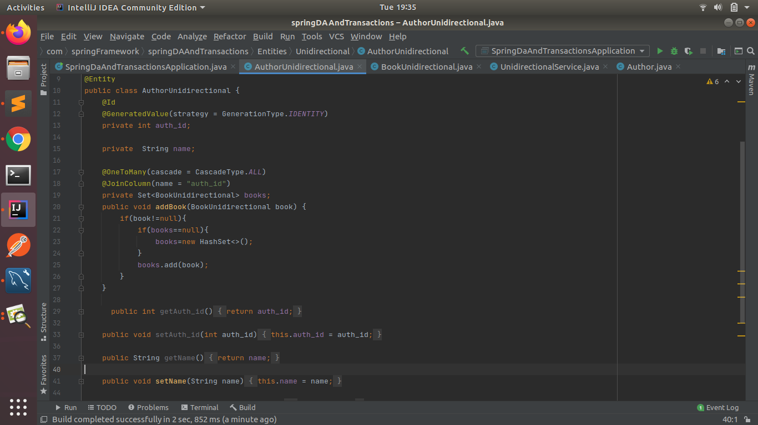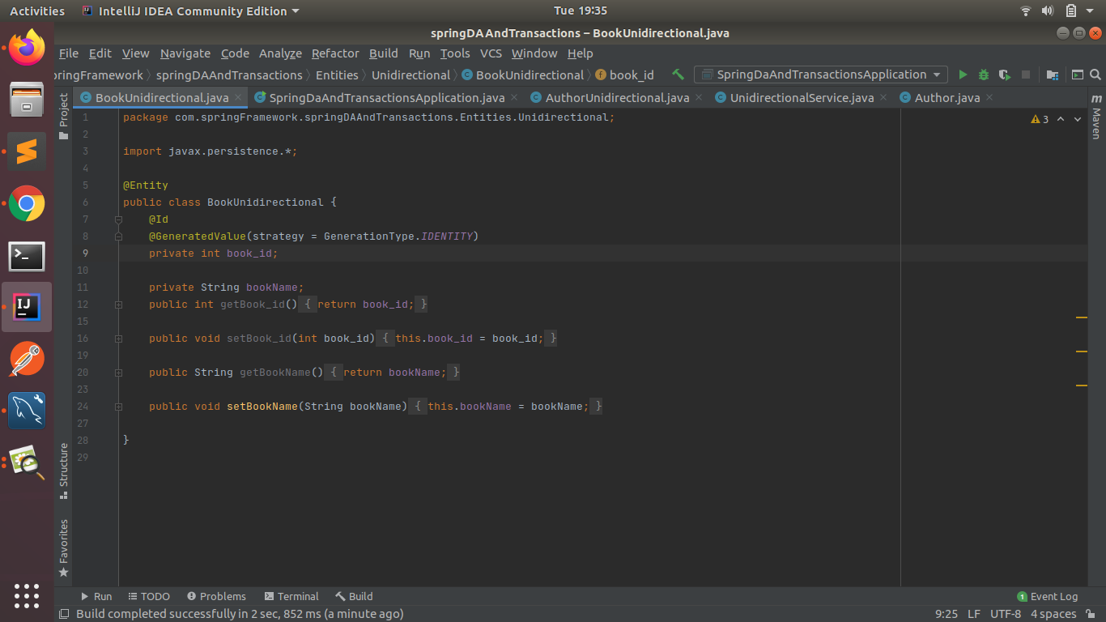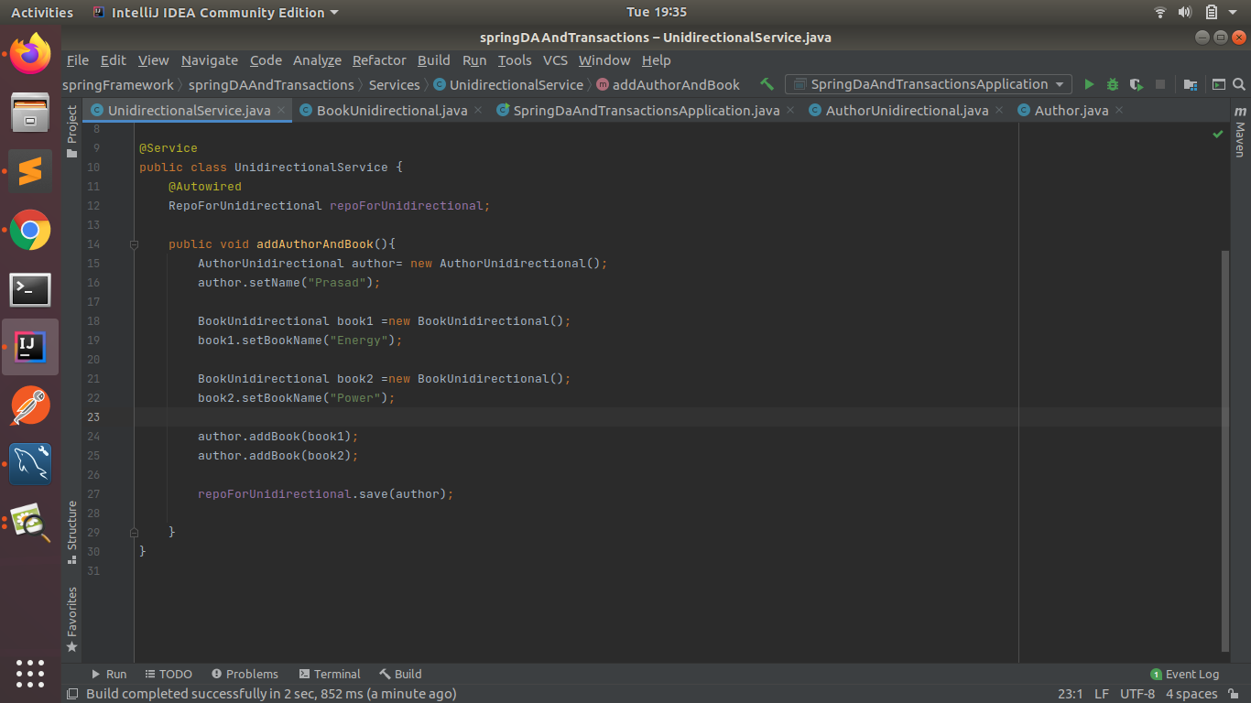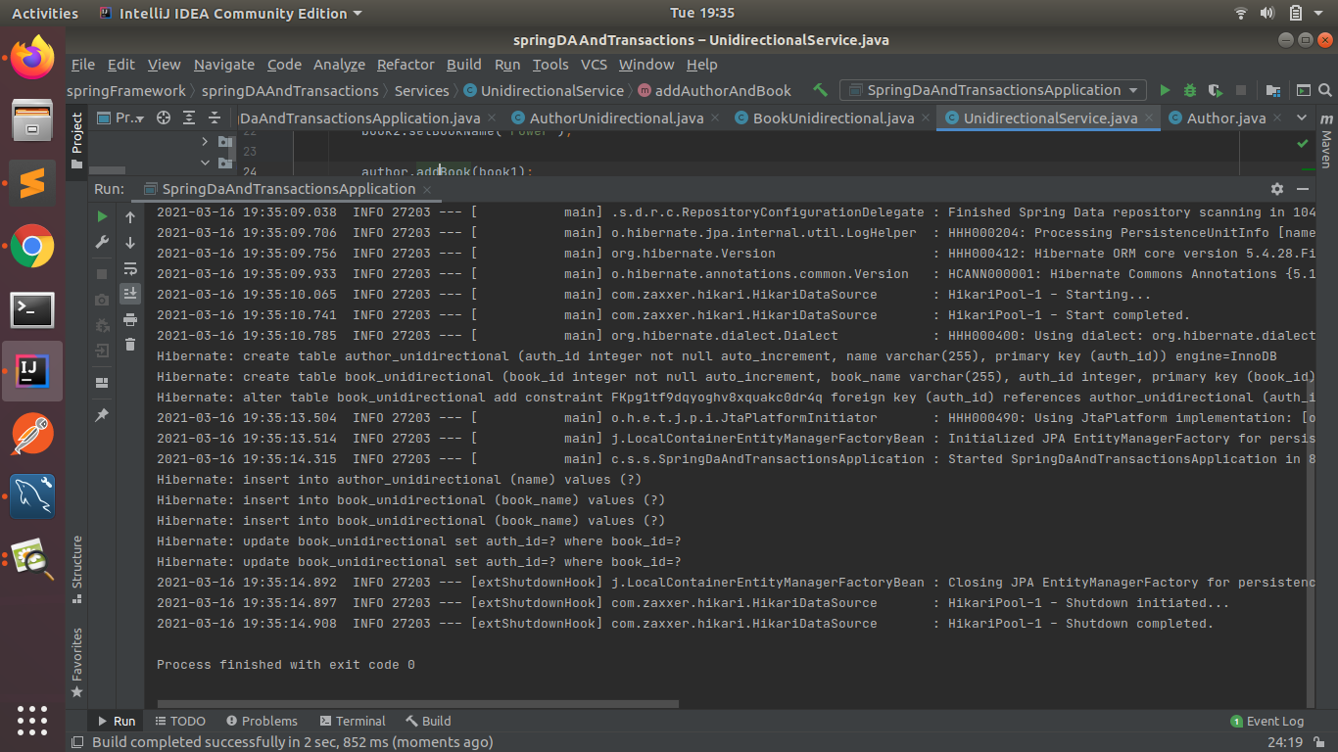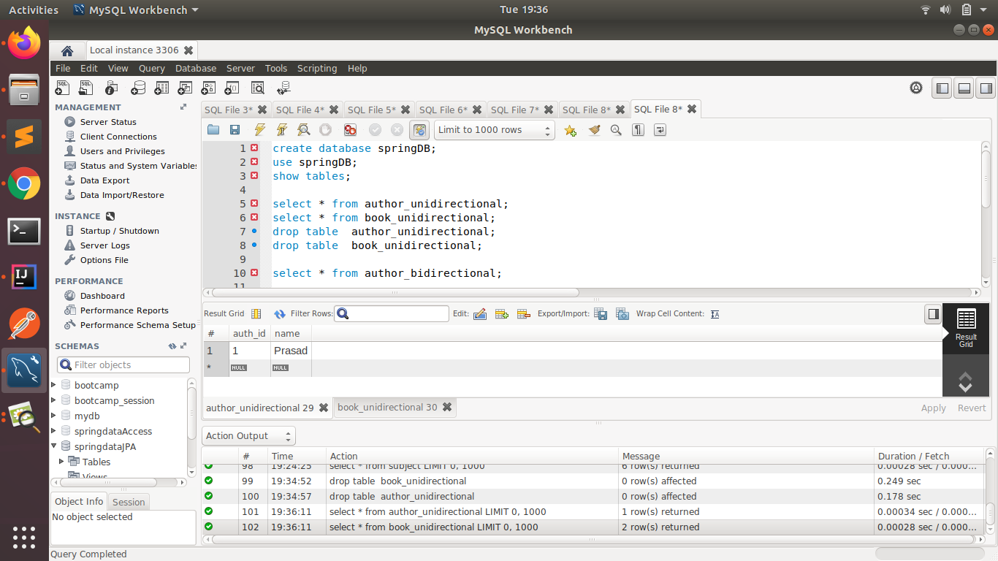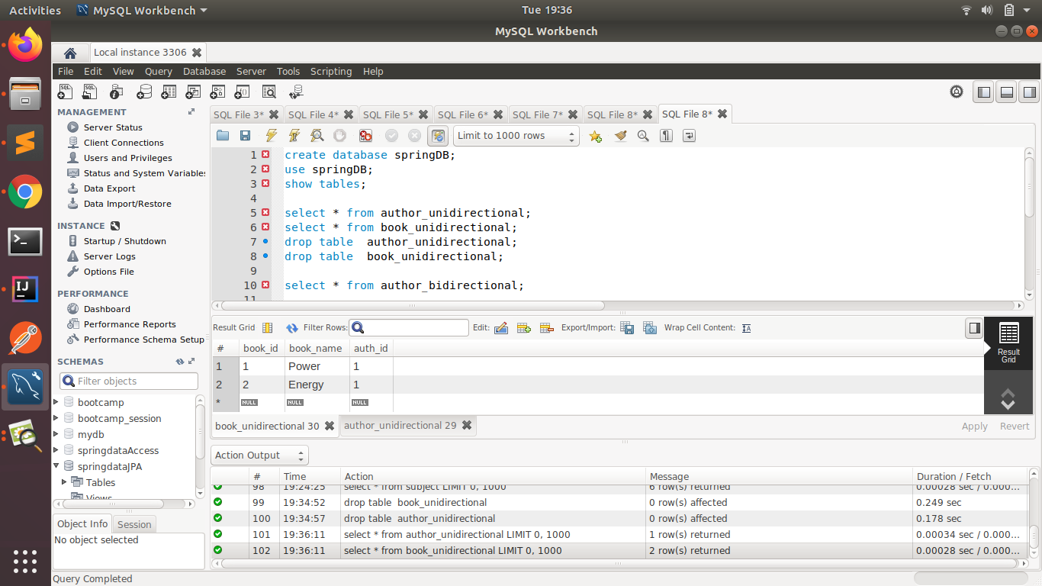

BIDIRECTIONAL:

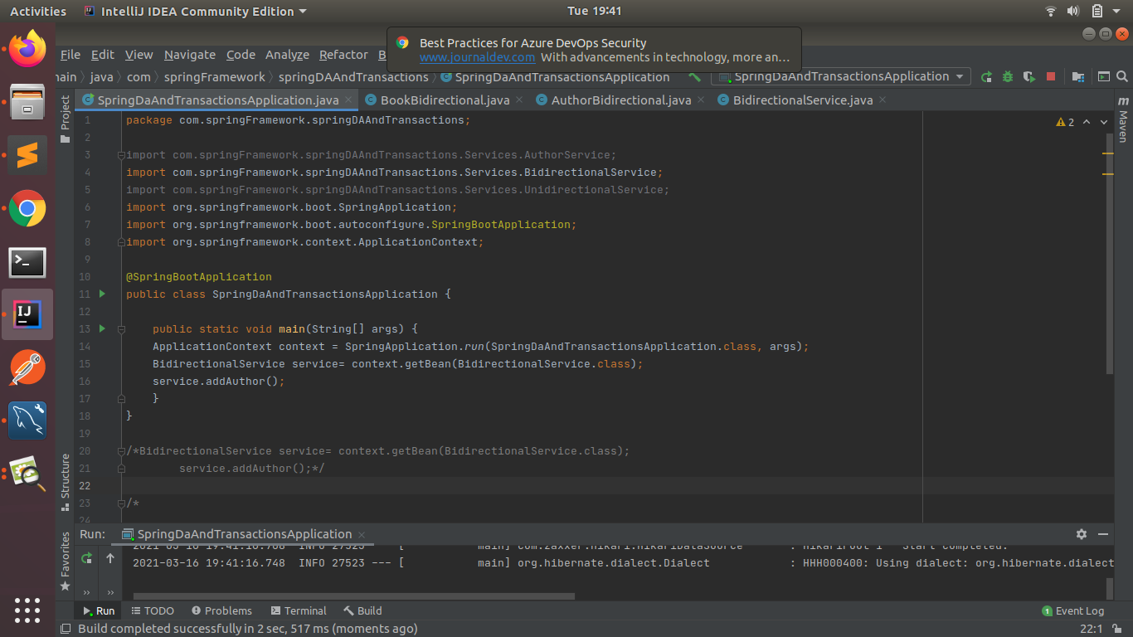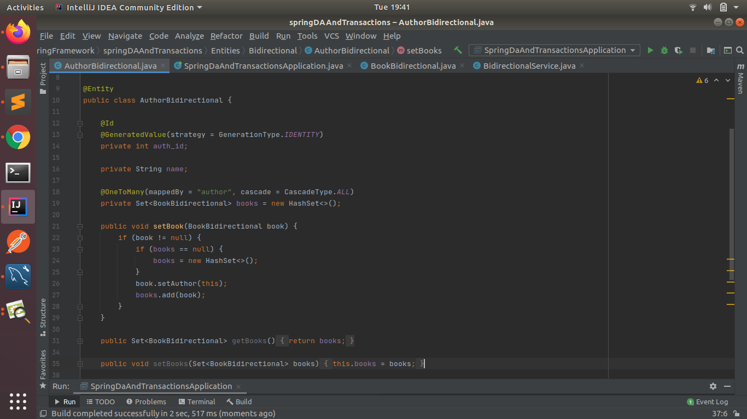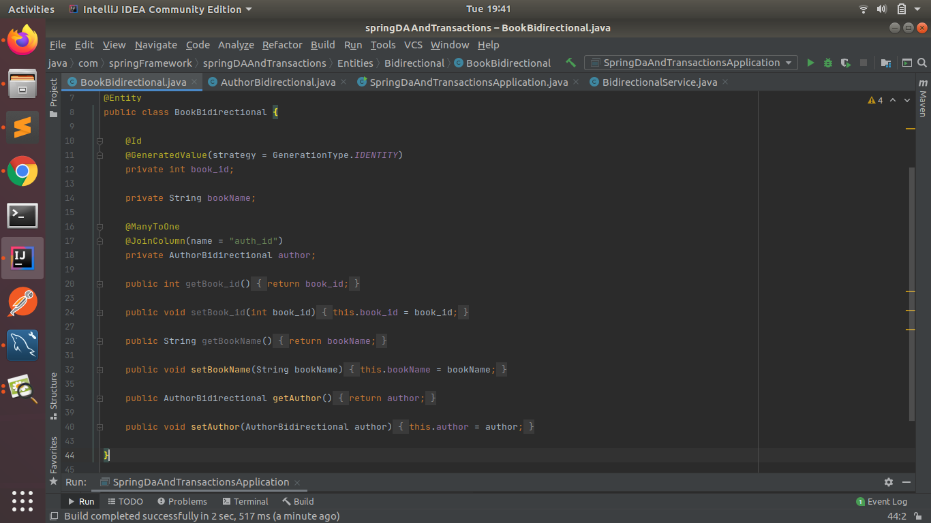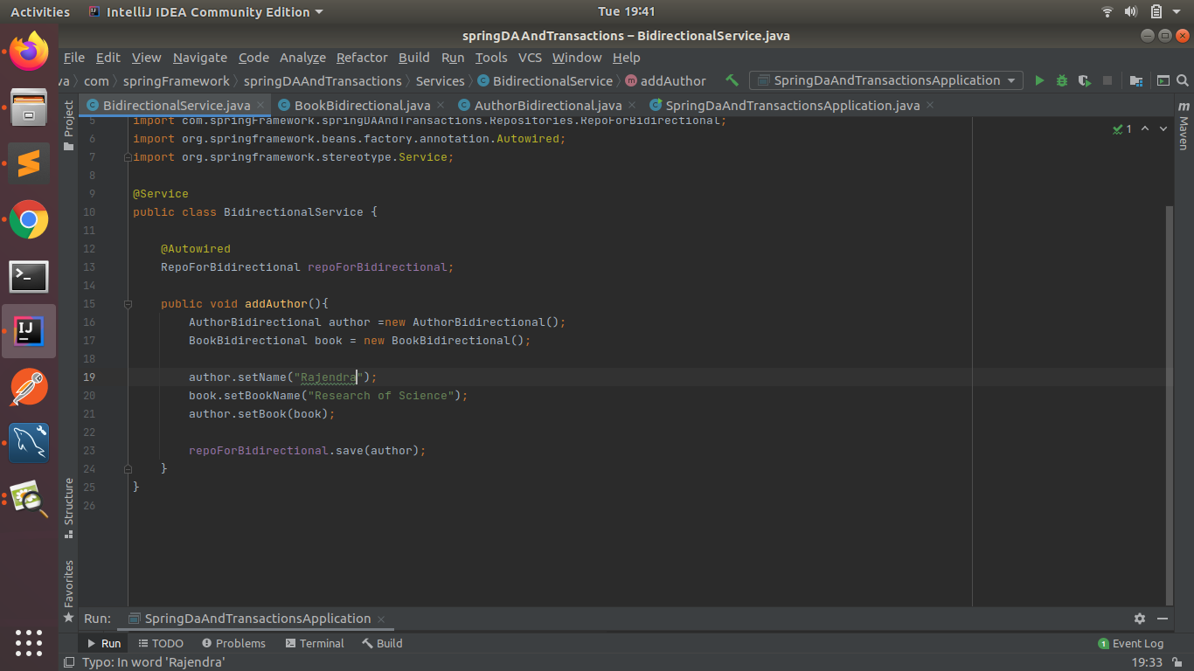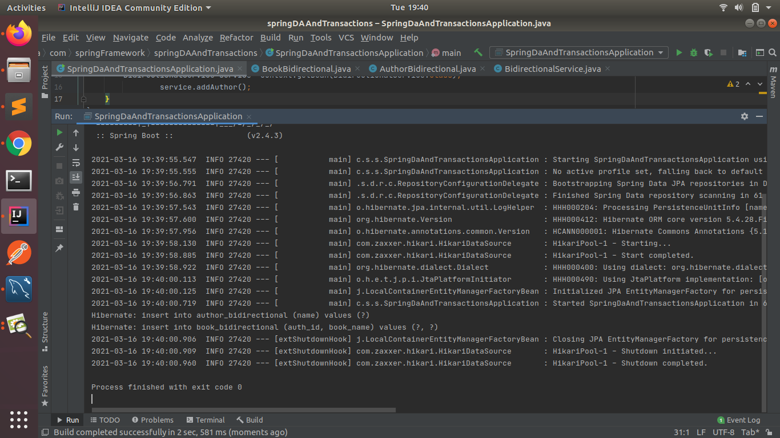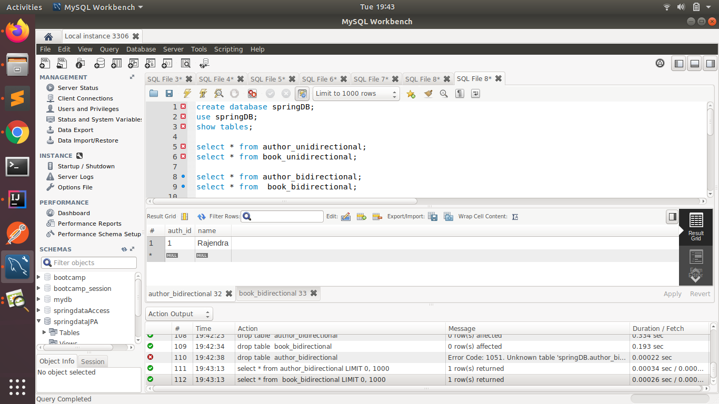

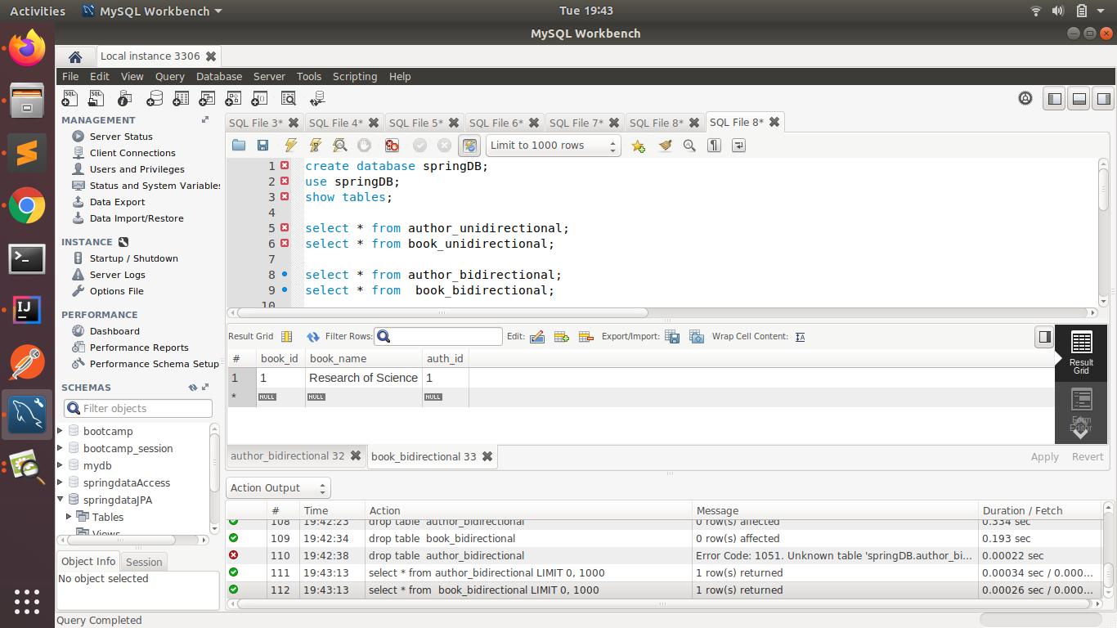

1. **Implement Many to Many Mapping between Author and Book.**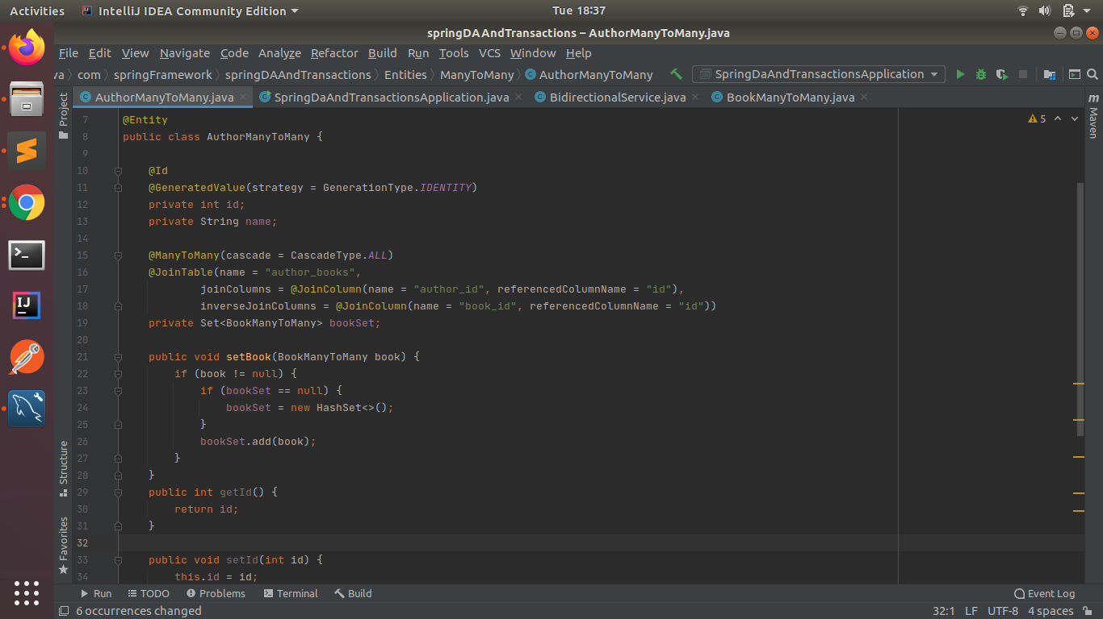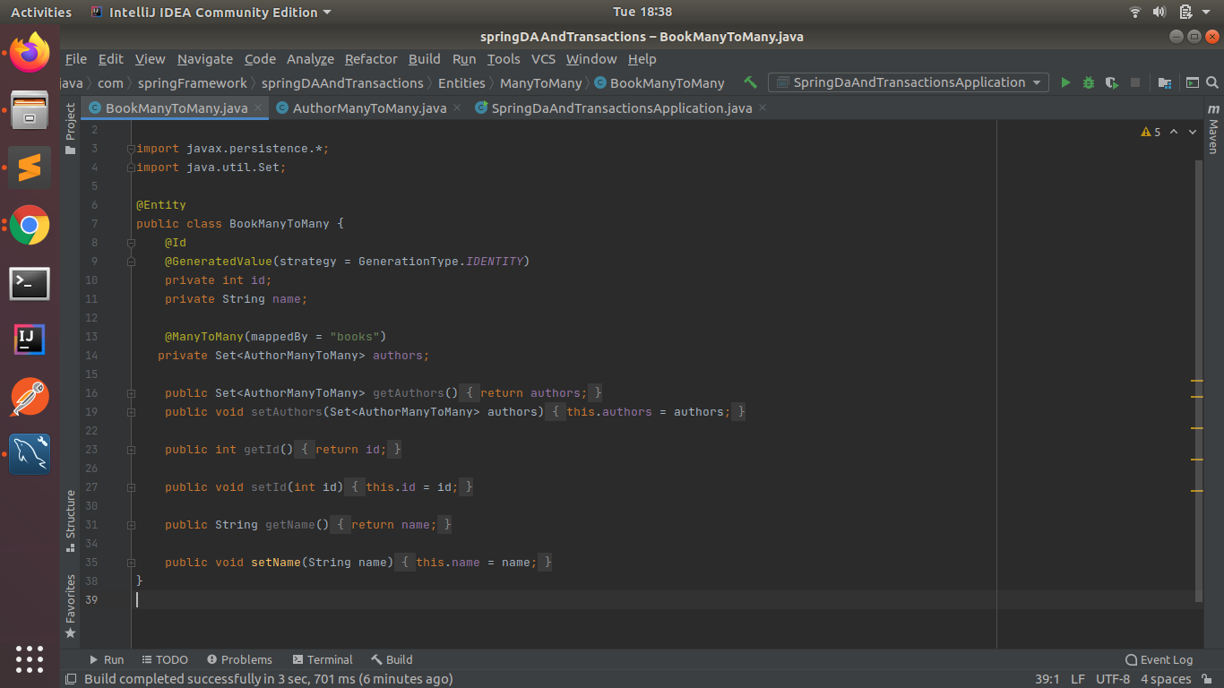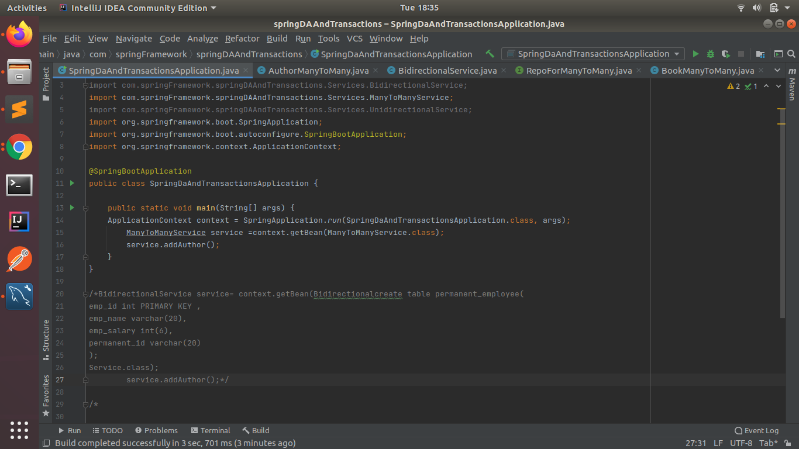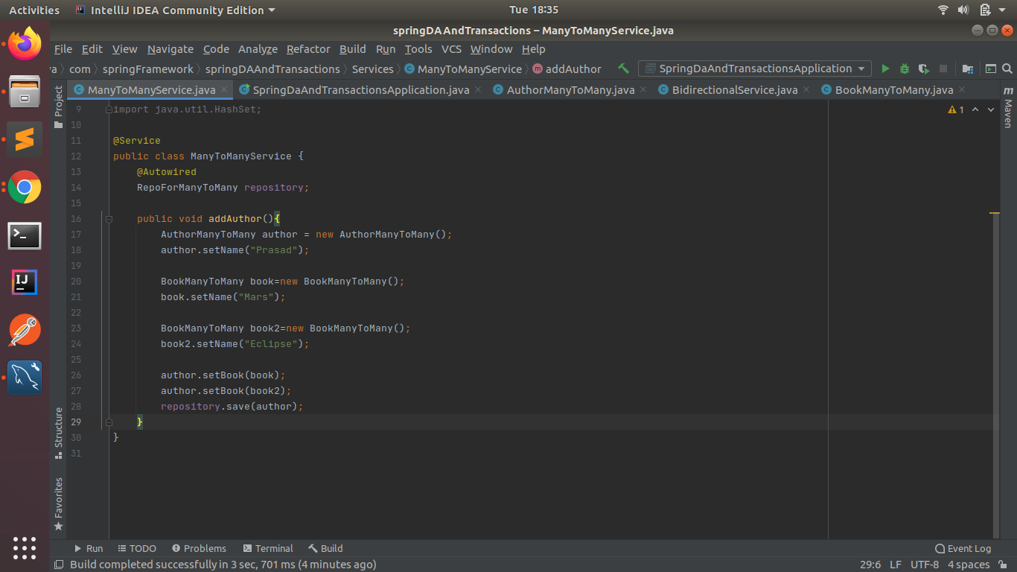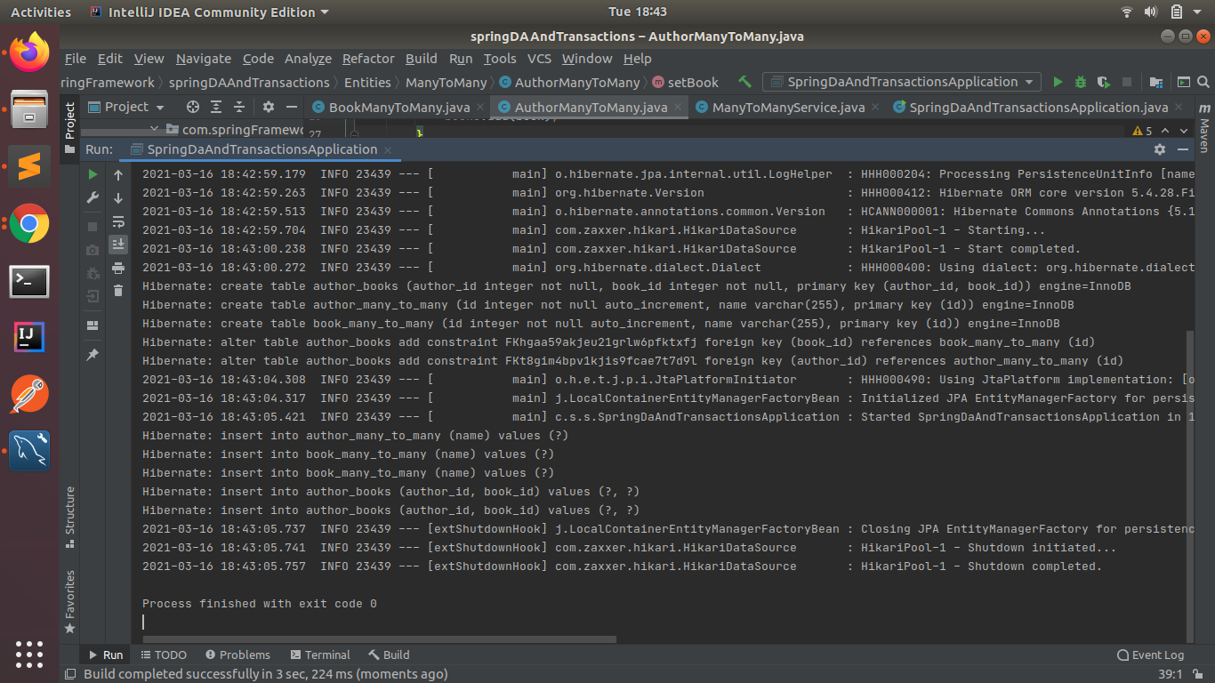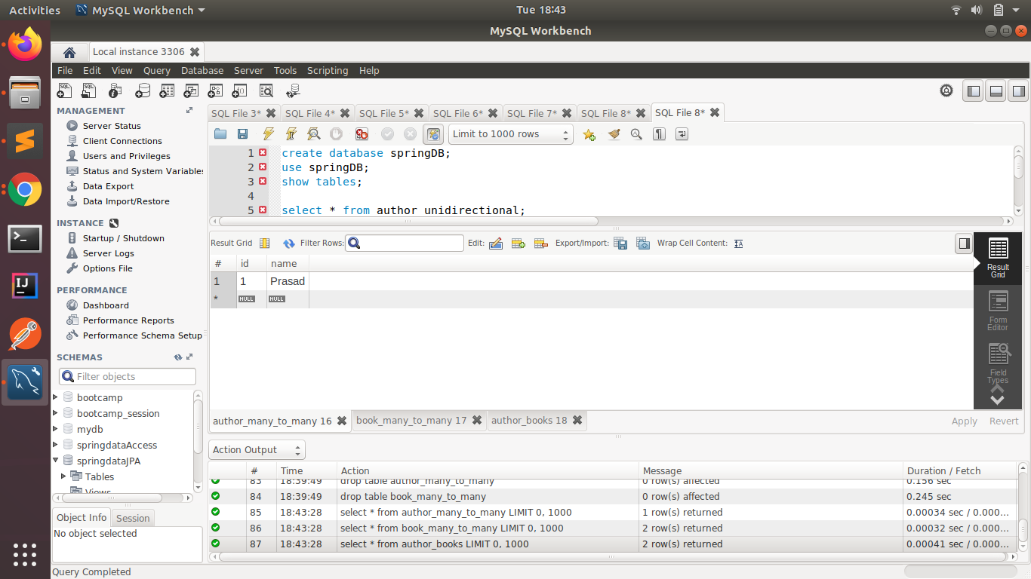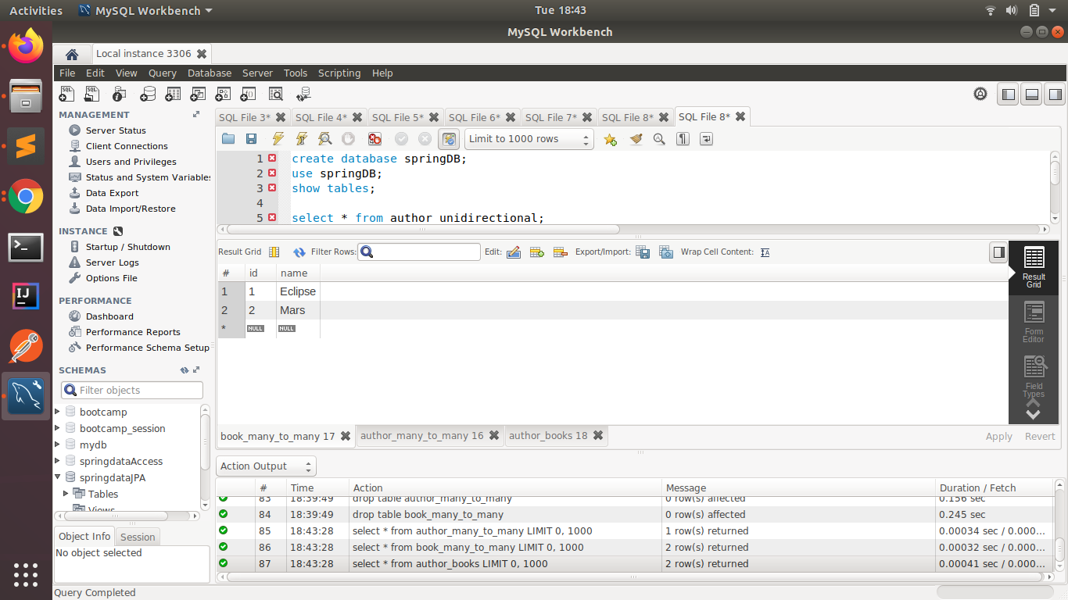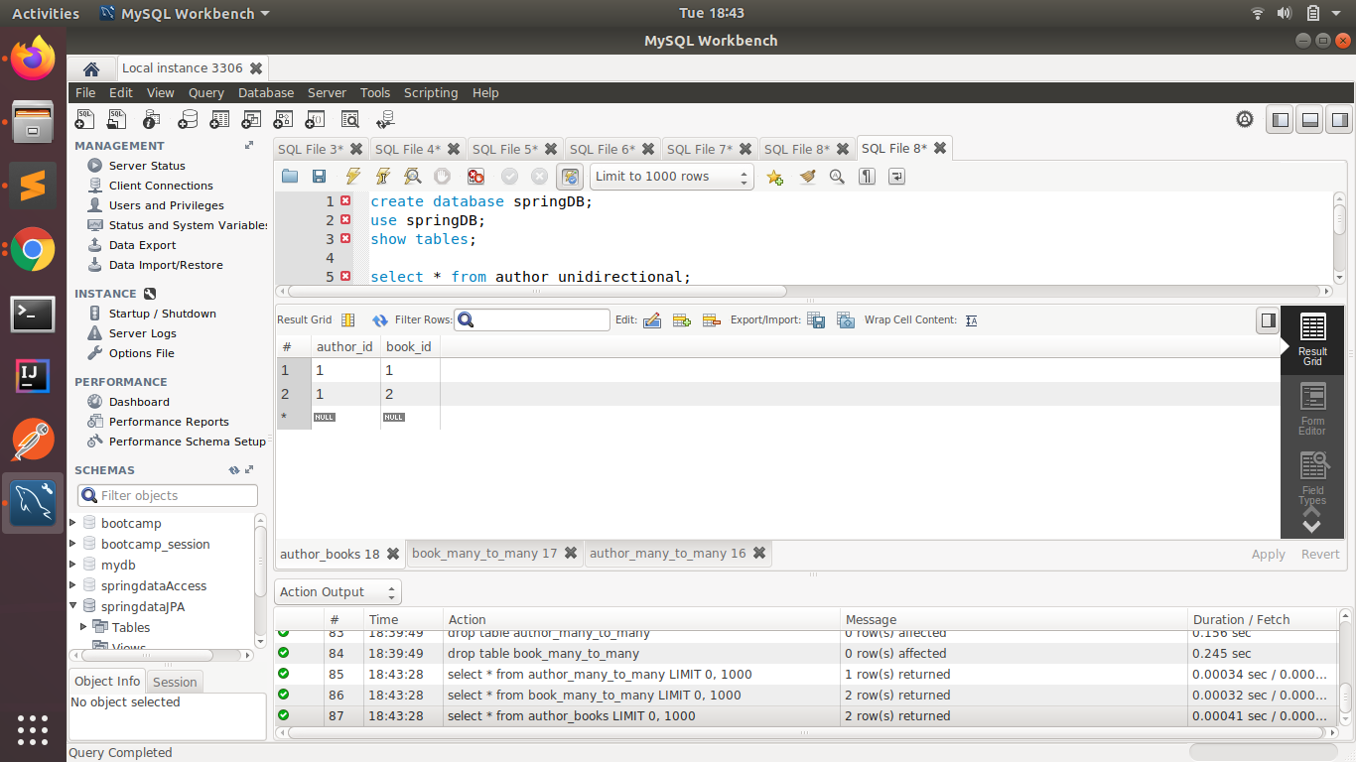
2. **Which method on the session object can be used to remove an object from the cache?**

evict() mehod is used to remove an object from the cache.

If you run two select statements together, the first statement will fetch the data from the database and store it in the cache. And when the second select statement will run it will fetch the data from the Cache. But if we want to remove the object from the Cache we will use **evict()** method so that the second select statement executes it again to fetch data from the database.

1. **What does @transactional annotation do?**

This annotation takes care of the database transactions. It starts the transaction with the database after the compilation of the taks it commits the transaction. If there is any exception in between the transaction it rolls back all the tasks leaving the database in stable state.